**YAZILIM-3 RAPORU**

**1-)**

**A-)**

**canberk

.MODEL MOSN NMOS LEVEL=2 LD=0.15U TOX=200.0E-10

+ NSUB=5.36726E+15 VTO=0.743469 KP=8.00059E-05 GAMMA=0.543

+ PHI=0.6 U0=655.881 UEXP=0.157282 UCRIT=31443.8

+ DELTA=2.39824 VMAX=55260.9 XJ=0.25U LAMBDA=0.0367072

+ NFS=1E+12 NEFF=1.001 NSS=1E+11 TPG=1.0 RSH=70.00

+ CGDO=4.3E-10 CGSO=4.3E-10 CJ=0.0003 MJ=0.6585

+ CJSW=8.0E-10 MJSW=0.2402 PB=0.58

M1 3 1 2 2 MOSN W=1.8u L=1.2u NRS=0.333 NRD=0.333

+ AD=6.5p PD=9.0u AS=6.5p PS=9.0u

VDD 4 0 3.1v

VIN 1 0 PULSE(0 3.1 0 1ns 1ns 5ns 10ns)

vss 2 0 0v

R1 3 4 100K

C1 3 0 1ff

.control

DC VIN 0 3.1 0.1

PLOT V(3) VS V(1)

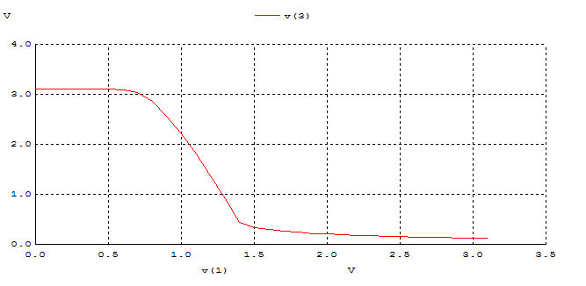.endc

**B-)**

**canberk

.MODEL MOSN NMOS LEVEL=2 LD=0.15U TOX=200.0E-10

+ NSUB=5.36726E+15 VTO=0.743469 KP=8.00059E-05 GAMMA=0.543

+ PHI=0.6 U0=655.881 UEXP=0.157282 UCRIT=31443.8

+ DELTA=2.39824 VMAX=55260.9 XJ=0.25U LAMBDA=0.0367072

+ NFS=1E+12 NEFF=1.001 NSS=1E+11 TPG=1.0 RSH=70.00

+ CGDO=4.3E-10 CGSO=4.3E-10 CJ=0.0003 MJ=0.6585

+ CJSW=8.0E-10 MJSW=0.2402 PB=0.58

.MODEL MOSP PMOS LEVEL=2 LD=0.15U TOX=200.0E-10

+ NSUB=4.3318E+15 VTO=-0.738861 KP=2.70E-05 GAMMA=0.58

+ PHI=0.6 U0=261.977 UEXP=0.323932 UCRIT=65719.8

+ DELTA=1.79192 VMAX=25694 XJ=0.25U LAMBDA=0.0612279

+ NFS=1E+12 NEFF=1.001 NSS=1E+11 TPG=-1.0 RSH=120.6

+ CGDO=4.3E-10 CGSO=4.3E-10 CJ=0.0005 MJ=0.5052

+ CJSW=1.349E-10 MJSW=0.2417 PB=0.64

M1 2 0 3 3 MOSP W=1.8u L=1.2u NRS=0.333 NRD=0.333

+ AD=6.5p PD=9.0u AS=6.5p PS=9.0u

M2 2 1 0 0 MOSN W=1.8u L=1.2u NRS=0.333 NRD=0.333

+ AD=6.5p PD=9.0u AS=6.5p PS=9.0u

VDD 3 0 DC 3.1

VIN 1 0 PULSE(0 3.1 0 1ns 1ns 5ns 10ns)

C1 2 0 1fF

.control

DC VIN 0 3.1 0.01

PLOT V(2) VS V(1)

.endc

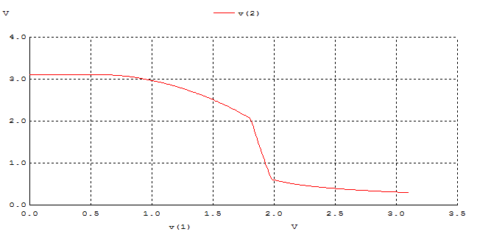

**C-)**

**canberk

.MODEL MOSN NMOS LEVEL=2 LD=0.15U TOX=200.0E-10

+ NSUB=5.36726E+15 VTO=0.743469 KP=8.00059E-05 GAMMA=0.543

+ PHI=0.6 U0=655.881 UEXP=0.157282 UCRIT=31443.8

+ DELTA=2.39824 VMAX=55260.9 XJ=0.25U LAMBDA=0.0367072

+ NFS=1E+12 NEFF=1.001 NSS=1E+11 TPG=1.0 RSH=70.00

+ CGDO=4.3E-10 CGSO=4.3E-10 CJ=0.0003 MJ=0.6585

+ CJSW=8.0E-10 MJSW=0.2402 PB=0.58

.MODEL MOSP PMOS LEVEL=2 LD=0.15U TOX=200.0E-10

+ NSUB=4.3318E+15 VTO=-0.738861 KP=2.70E-05 GAMMA=0.58

+ PHI=0.6 U0=261.977 UEXP=0.323932 UCRIT=65719.8

+ DELTA=1.79192 VMAX=25694 XJ=0.25U LAMBDA=0.0612279

+ NFS=1E+12 NEFF=1.001 NSS=1E+11 TPG=-1.0 RSH=120.6

+ CGDO=4.3E-10 CGSO=4.3E-10 CJ=0.0005 MJ=0.5052

+ CJSW=1.349E-10 MJSW=0.2417 PB=0.64

M1 2 1 3 3 MOSP W=1.8u L=1.2u NRS=0.333 NRD=0.333

+ AD=6.5p PD=9.0u AS=6.5p PS=9.0u

VDD 3 0 DC 3.1

VIN 1 0 PULSE(0 3.1 0 1ns 1ns 5ns 10ns)

R1 2 0 100K

C1 2 0 1fF

.control

DC VIN 0 3.1 0.1

PLOT V(2) VS V(1)

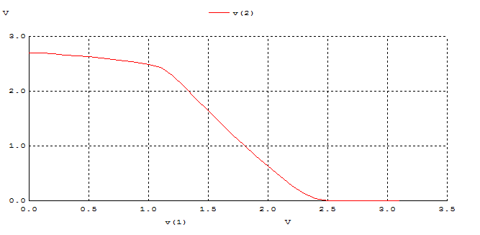.ENDC

**D-)**

**canberk

.MODEL MOSN NMOS LEVEL=2 LD=0.15U TOX=200.0E-10

+ NSUB=5.36726E+15 VTO=0.743469 KP=8.00059E-05 GAMMA=0.543

+ PHI=0.6 U0=655.881 UEXP=0.157282 UCRIT=31443.8

+ DELTA=2.39824 VMAX=55260.9 XJ=0.25U LAMBDA=0.0367072

+ NFS=1E+12 NEFF=1.001 NSS=1E+11 TPG=1.0 RSH=70.00

+ CGDO=4.3E-10 CGSO=4.3E-10 CJ=0.0003 MJ=0.6585

+ CJSW=8.0E-10 MJSW=0.2402 PB=0.58

.MODEL MOSP PMOS LEVEL=2 LD=0.15U TOX=200.0E-10

+ NSUB=4.3318E+15 VTO=-0.738861 KP=2.70E-05 GAMMA=0.58

+ PHI=0.6 U0=261.977 UEXP=0.323932 UCRIT=65719.8

+ DELTA=1.79192 VMAX=25694 XJ=0.25U LAMBDA=0.0612279

+ NFS=1E+12 NEFF=1.001 NSS=1E+11 TPG=-1.0 RSH=120.6

+ CGDO=4.3E-10 CGSO=4.3E-10 CJ=0.0005 MJ=0.5052

+ CJSW=1.349E-10 MJSW=0.2417 PB=0.64

M1 2 1 3 3 MOSP W=1.8u L=1.2u NRS=0.333 NRD=0.333

+ AD=6.5p PD=9.0u AS=6.5p PS=9.0u

M2 2 1 0 0 MOSN W=1.8u L=1.2u NRS=0.333 NRD=0.333

+ AD=6.5p PD=9.0u AS=6.5p PS=9.0u

VDD 3 0 DC 3.1

VIN 1 0 PULSE(0 5 0 1ns 1ns 5ns 10ns)

C1 2 0 1F

.control

DC VIN 0 5 0.1

PLOT V(2) VS V(1)

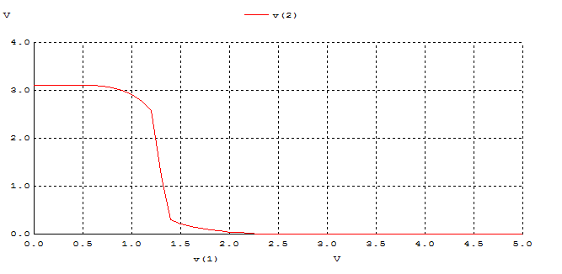.ENDC

**Tablo 1- DC analiz sonuçları**

|  |  |  |  |  |  |  |  |
| --- | --- | --- | --- | --- | --- | --- | --- |
|  | VOH | VOL | VIH | VIL | VM | NMH | NML |
| A |  |  |  |  |  |  |  |
| B |  |  |  |  |  |  |  |
| C |  |  |  |  |  |  |  |
| D |  |  |  |  |  |  |  |

**2)**

**A)**

**canberk

.MODEL MOSN NMOS LEVEL=2 LD=0.15U TOX=200.0E-10

+ NSUB=5.36726E+15 VTO=0.743469 KP=8.00059E-05 GAMMA=0.543

+ PHI=0.6 U0=655.881 UEXP=0.157282 UCRIT=31443.8

+ DELTA=2.39824 VMAX=55260.9 XJ=0.25U LAMBDA=0.0367072

+ NFS=1E+12 NEFF=1.001 NSS=1E+11 TPG=1.0 RSH=70.00

+ CGDO=4.3E-10 CGSO=4.3E-10 CJ=0.0003 MJ=0.6585

+ CJSW=8.0E-10 MJSW=0.2402 PB=0.58

.MODEL MOSP PMOS LEVEL=2 LD=0.15U TOX=200.0E-10

+ NSUB=4.3318E+15 VTO=-0.738861 KP=2.70E-05 GAMMA=0.58

+ PHI=0.6 U0=261.977 UEXP=0.323932 UCRIT=65719.8

+ DELTA=1.79192 VMAX=25694 XJ=0.25U LAMBDA=0.0612279

+ NFS=1E+12 NEFF=1.001 NSS=1E+11 TPG=-1.0 RSH=120.6

+ CGDO=4.3E-10 CGSO=4.3E-10 CJ=0.0005 MJ=0.5052

+ CJSW=1.349E-10 MJSW=0.2417 PB=0.64

M1 2 1 0 0 MOSN W=1.8u L=1.2u NRS=0.333 NRD=0.333

+ AD=6.5p PD=9.0u AS=6.5p PS=9.0u

VDD 3 0 DC 3.1

VIN 1 0 PULSE(0 3.1 0 1ns 1ns 4ns 10ns)

R1 3 2 100K

C1 2 0 1fF

.control

TRAN 0.1NS 20NS

PLOT V(2) V(1)

.ENDC

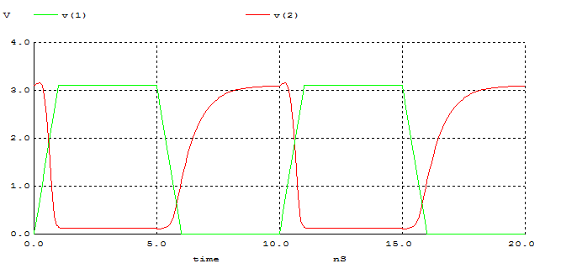

**B)**

**canberk

.MODEL MOSN NMOS LEVEL=2 LD=0.15U TOX=200.0E-10

+ NSUB=5.36726E+15 VTO=0.743469 KP=8.00059E-05 GAMMA=0.543

+ PHI=0.6 U0=655.881 UEXP=0.157282 UCRIT=31443.8

+ DELTA=2.39824 VMAX=55260.9 XJ=0.25U LAMBDA=0.0367072

+ NFS=1E+12 NEFF=1.001 NSS=1E+11 TPG=1.0 RSH=70.00

+ CGDO=4.3E-10 CGSO=4.3E-10 CJ=0.0003 MJ=0.6585

+ CJSW=8.0E-10 MJSW=0.2402 PB=0.58

.MODEL MOSP PMOS LEVEL=2 LD=0.15U TOX=200.0E-10

+ NSUB=4.3318E+15 VTO=-0.738861 KP=2.70E-05 GAMMA=0.58

+ PHI=0.6 U0=261.977 UEXP=0.323932 UCRIT=65719.8

+ DELTA=1.79192 VMAX=25694 XJ=0.25U LAMBDA=0.0612279

+ NFS=1E+12 NEFF=1.001 NSS=1E+11 TPG=-1.0 RSH=120.6

+ CGDO=4.3E-10 CGSO=4.3E-10 CJ=0.0005 MJ=0.5052

+ CJSW=1.349E-10 MJSW=0.2417 PB=0.64

M1 2 0 3 3 MOSP W=1.8u L=1.2u NRS=0.333 NRD=0.333

+ AD=6.5p PD=9.0u AS=6.5p PS=9.0u

M2 2 1 0 0 MOSN W=1.8u L=1.2u NRS=0.333 NRD=0.333

+ AD=6.5p PD=9.0u AS=6.5p PS=9.0u

VDD 3 0 DC 3.1

VIN 1 0 PULSE(0 3.1 0 1ns 1ns 4ns 10ns)

C1 2 0 1fF

.control

TRAN 0.1NS 20NS

PLOT V(2) V(1)

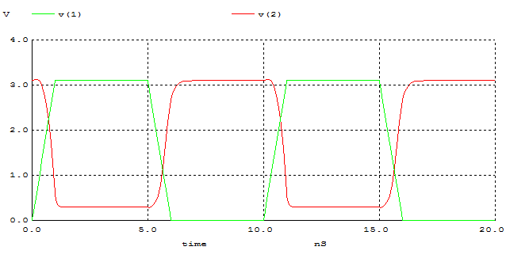.ENDC

**C)**

**canberk

.MODEL MOSN NMOS LEVEL=2 LD=0.15U TOX=200.0E-10

+ NSUB=5.36726E+15 VTO=0.743469 KP=8.00059E-05 GAMMA=0.543

+ PHI=0.6 U0=655.881 UEXP=0.157282 UCRIT=31443.8

+ DELTA=2.39824 VMAX=55260.9 XJ=0.25U LAMBDA=0.0367072

+ NFS=1E+12 NEFF=1.001 NSS=1E+11 TPG=1.0 RSH=70.00

+ CGDO=4.3E-10 CGSO=4.3E-10 CJ=0.0003 MJ=0.6585

+ CJSW=8.0E-10 MJSW=0.2402 PB=0.58

.MODEL MOSP PMOS LEVEL=2 LD=0.15U TOX=200.0E-10

+ NSUB=4.3318E+15 VTO=-0.738861 KP=2.70E-05 GAMMA=0.58

+ PHI=0.6 U0=261.977 UEXP=0.323932 UCRIT=65719.8

+ DELTA=1.79192 VMAX=25694 XJ=0.25U LAMBDA=0.0612279

+ NFS=1E+12 NEFF=1.001 NSS=1E+11 TPG=-1.0 RSH=120.6

+ CGDO=4.3E-10 CGSO=4.3E-10 CJ=0.0005 MJ=0.5052

+ CJSW=1.349E-10 MJSW=0.2417 PB=0.64

M1 2 1 3 3 MOSP W=1.8u L=1.2u NRS=0.333 NRD=0.333

+ AD=6.5p PD=9.0u AS=6.5p PS=9.0u

VDD 3 0 DC 3.1

VIN 1 0 PULSE(0 3.1 0 1ns 1ns 4ns 10ns)

R1 2 0 100K

C1 2 0 1fF

.control

TRAN 0.1NS 20NS

PLOT V(2) V(1)

.ENDC

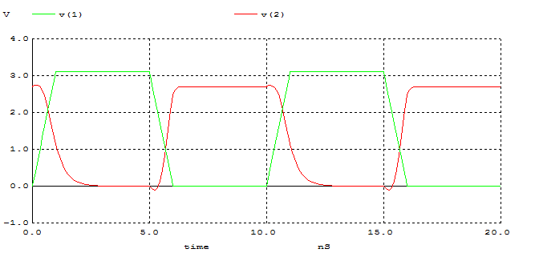

**D)**

**canberk

.MODEL MOSN NMOS LEVEL=2 LD=0.15U TOX=200.0E-10

+ NSUB=5.36726E+15 VTO=0.743469 KP=8.00059E-05 GAMMA=0.543

+ PHI=0.6 U0=655.881 UEXP=0.157282 UCRIT=31443.8

+ DELTA=2.39824 VMAX=55260.9 XJ=0.25U LAMBDA=0.0367072

+ NFS=1E+12 NEFF=1.001 NSS=1E+11 TPG=1.0 RSH=70.00

+ CGDO=4.3E-10 CGSO=4.3E-10 CJ=0.0003 MJ=0.6585

+ CJSW=8.0E-10 MJSW=0.2402 PB=0.58

.MODEL MOSP PMOS LEVEL=2 LD=0.15U TOX=200.0E-10

+ NSUB=4.3318E+15 VTO=-0.738861 KP=2.70E-05 GAMMA=0.58

+ PHI=0.6 U0=261.977 UEXP=0.323932 UCRIT=65719.8

+ DELTA=1.79192 VMAX=25694 XJ=0.25U LAMBDA=0.0612279

+ NFS=1E+12 NEFF=1.001 NSS=1E+11 TPG=-1.0 RSH=120.6

+ CGDO=4.3E-10 CGSO=4.3E-10 CJ=0.0005 MJ=0.5052

+ CJSW=1.349E-10 MJSW=0.2417 PB=0.64

M1 2 1 3 3 MOSP W=1.8u L=1.2u NRS=0.333 NRD=0.333

+ AD=6.5p PD=9.0u AS=6.5p PS=9.0u

M2 2 1 0 0 MOSN W=1.8u L=1.2u NRS=0.333 NRD=0.333

+ AD=6.5p PD=9.0u AS=6.5p PS=9.0u

VDD 3 0 DC 3.1

VIN 1 0 PULSE(0 3.1 0 1ns 1ns 4ns 10ns)

C1 2 0 1fF

.control

TRAN 0.1NS 20NS

PLOT V(2) V(1)

.ENDC

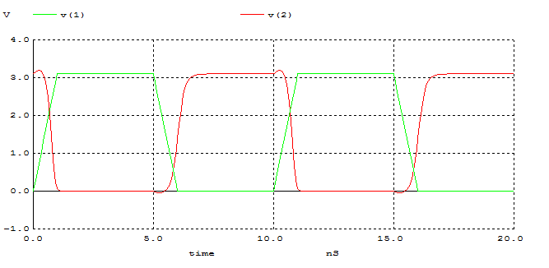

**Tablo 2 - Dinamik durum için ölçüm sonuçları**

|  |  |  |  |  |  |
| --- | --- | --- | --- | --- | --- |
|  | tr | tf | tpLH | tpHL | td |
| A |  |  |  |  |  |
| B |  |  |  |  |  |
| C |  |  |  |  |  |
| D |  |  |  |  |  |

**3)**

**A)**

**B)**

**4)**

**canberk

.MODEL MOSN NMOS LEVEL=2 LD=0.15U TOX=200.0E-10

+ NSUB=5.36726E+15 VTO=0.743469 KP=8.00059E-05 GAMMA=0.543

+ PHI=0.6 U0=655.881 UEXP=0.157282 UCRIT=31443.8

+ DELTA=2.39824 VMAX=55260.9 XJ=0.25U LAMBDA=0.0367072

+ NFS=1E+12 NEFF=1.001 NSS=1E+11 TPG=1.0 RSH=70.00

+ CGDO=4.3E-10 CGSO=4.3E-10 CJ=0.0003 MJ=0.6585

+ CJSW=8.0E-10 MJSW=0.2402 PB=0.58

.MODEL MOSP PMOS LEVEL=2 LD=0.15U TOX=200.0E-10

+ NSUB=4.3318E+15 VTO=-0.738861 KP=2.70E-05 GAMMA=0.58

+ PHI=0.6 U0=261.977 UEXP=0.323932 UCRIT=65719.8

+ DELTA=1.79192 VMAX=25694 XJ=0.25U LAMBDA=0.0612279

+ NFS=1E+12 NEFF=1.001 NSS=1E+11 TPG=-1.0 RSH=120.6

+ CGDO=4.3E-10 CGSO=4.3E-10 CJ=0.0005 MJ=0.5052

+ CJSW=1.349E-10 MJSW=0.2417 PB=0.64

M1 2 1 3 3 MOSP W=5.4u L=1.2u NRS=0.111 NRD=0.111

+ AD=16.2p PD=11.4u AS=16.2p PS=11.4u

M2 2 1 0 0 MOSN W=1.8u L=1.2u NRS=0.333 NRD=0.333

+ AD=6.5p PD=9.0u AS=6.5p PS=9.0u

VDD 3 0 DC 3.1

VIN 1 0 PULSE(0 5 0 1ns 1ns 5ns 10ns)

C1 2 0 1F

.control

DC VIN 0 5 0.1

PLOT V(2) VS V(1)

.ENDC

